SCHOOL ATTENDANCE TRACKER
@CREATIVITY THINK (9483175986/7019689991)

ABSTRACT:
The School Attendance Tracker is a web-based platform designed to streamline daily attendance management for schools, colleges, and coaching centers. Users can log in, mark attendance, monitor student dashboards, generate reports, and send notifications to parents. Administrators manage classes, student records, analytics, and communication. Developed using Django and Django Rest Framework on the backend and React with React-Table and Axios on the frontend, the system ensures fast processing, secure data handling, and accurate reporting. It enhances transparency, reduces manual errors, and supports data-driven decision-making for educational institutions..

INTRODUCTION OF THE PROJECT:
Attendance monitoring is a critical activity for educational institutions, yet manual processes often lead to inaccuracies, delays, and communication gaps. The School Attendance Tracker simplifies this workflow by providing an online platform for marking attendance, generating reports, notifying parents, and analyzing attendance trends. Teachers can manage daily attendance efficiently, while administrators gain insights through analytics dashboards. Built with a scalable backend using Django and an interactive frontend using React, the platform enables institutions to modernize attendance management and ensure reliability, transparency, and improved communication with parents..

PROJECT OBJECTIVES:

• To build an online attendance management platform for educational institutions
• To allow teachers to mark daily attendance accurately and quickly
• To provide automated notifications for parents regarding student status
• To generate real-time attendance reports for analysis
• To enable administrators to manage classes, records, and analytics
• To reduce manual errors and save time through automation
• To centralize attendance records in a secure database

PROBLEM OF THE STATEMENT:
Educational institutions often rely on manual attendance systems that are prone to errors, delays, and lack of transparency. Teachers face difficulty maintaining records, administrators struggle with generating analytics, and parents do not always receive timely information about student attendance. Additionally, large institutions require a centralized system to manage classes, students, records, and communication efficiently. The School Attendance Tracker addresses these challenges by providing a web-based platform that automates attendance marking, reporting, communication, and analytics for schools and learning centers..

MOTIVATION OF THE PROJECT:
• Improve accuracy and reliability of attendance recording
• Provide real-time communication to parents regarding student presence
• Reduce the workload on teachers and administrators
• Offer insight through analytics for institution-level improvements
• Replace manual and paper-based processes with digital automation

BLOCK DAIGRAM OF PROJECT:

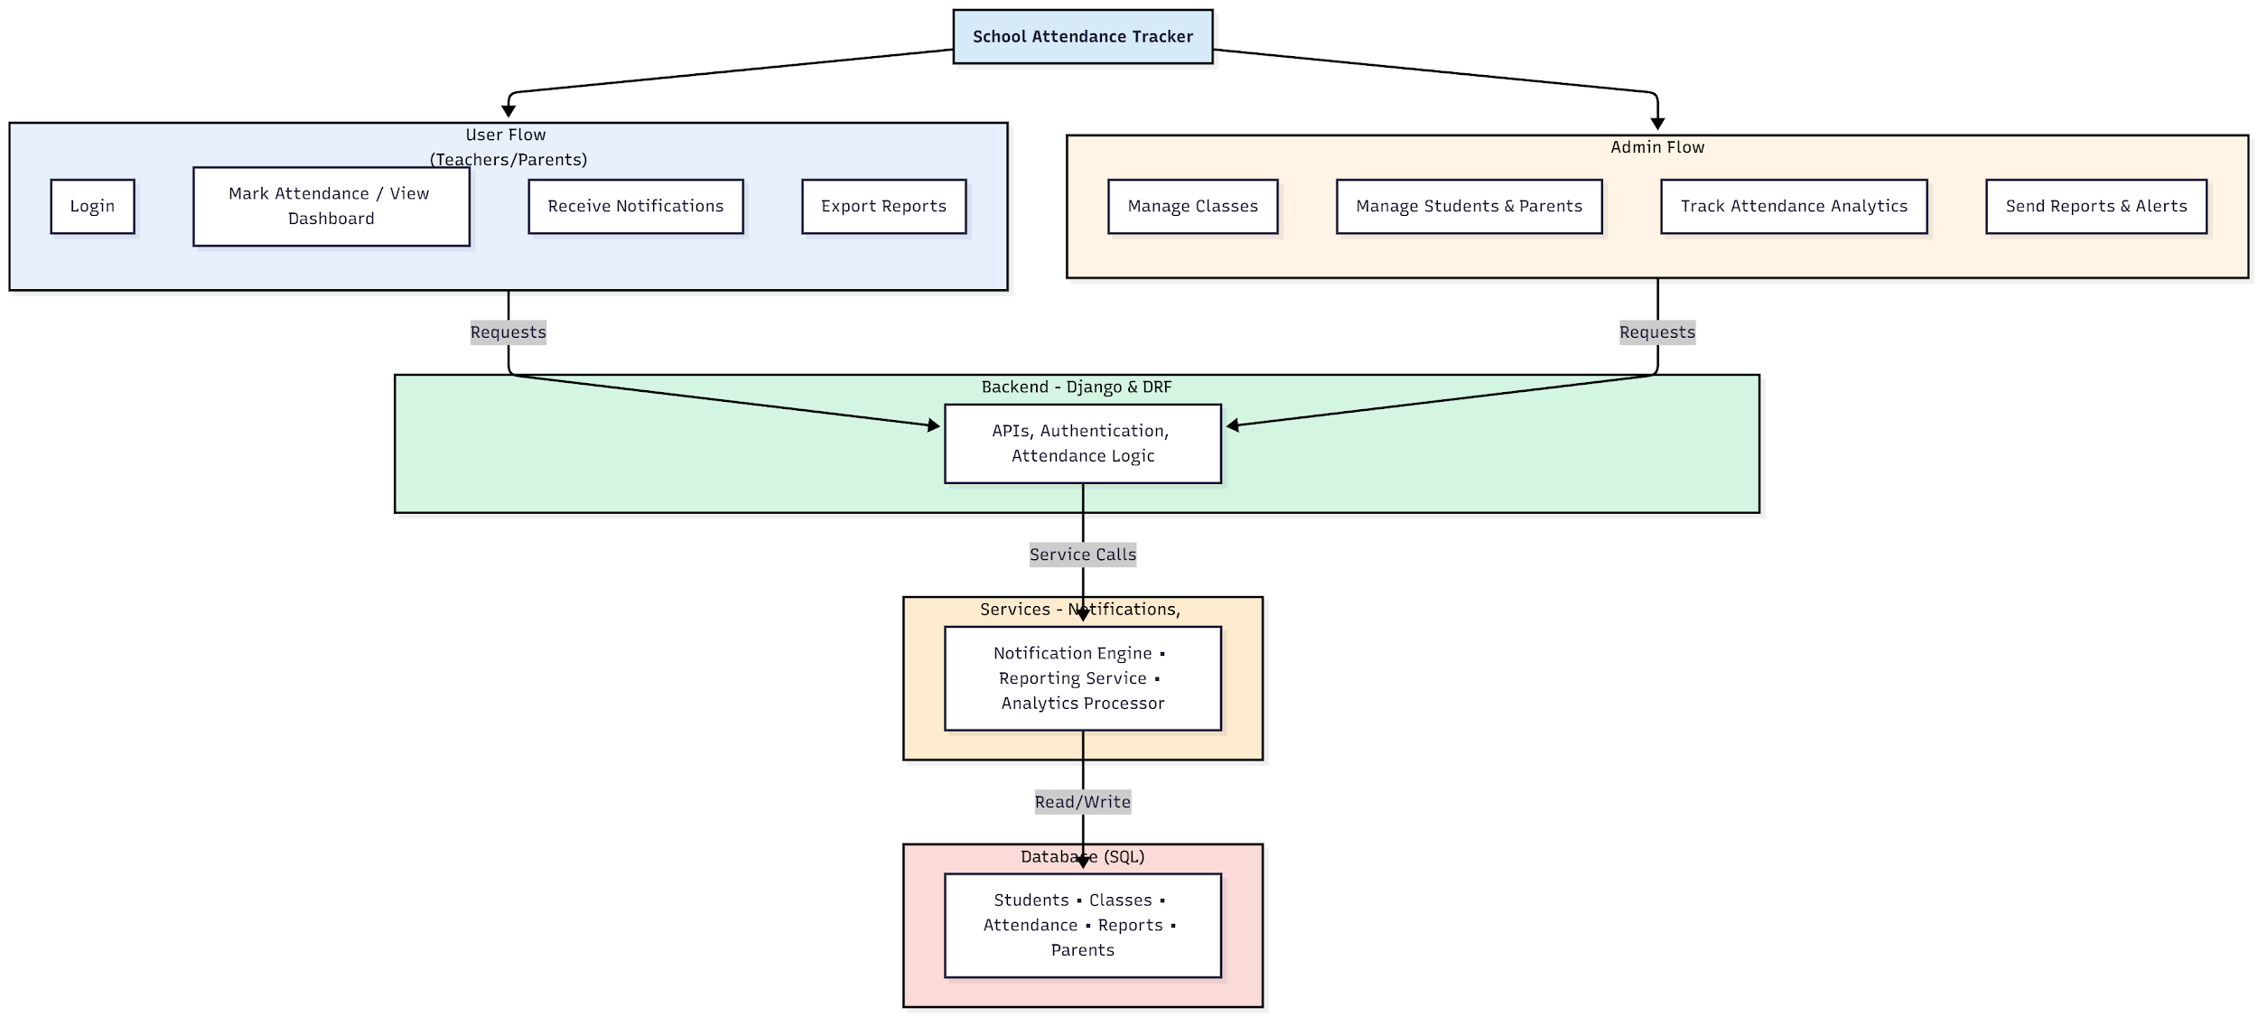

WORKING OF THE PROJECT:
The School Attendance Tracker begins with users logging into the system, where teachers can mark daily attendance through an intuitive interface. Attendance records are instantly processed by the backend and reflected on student dashboards. Parents receive real-time notifications regarding attendance updates, while administrators access analytics showing trends, class-wise summaries, and individual student histories. The backend manages authentication, validation, and attendance logic, while services handle reporting, analytics, and messaging. All data is securely stored in a centralized SQL database, ensuring accurate records and streamlined workflows for teachers, parents, and administrators..

SOFTWARE REQUIREMENT:
- Backend:
  - Python 3.x
  - Django
  - Django REST Framework
  - SQLite/PostgreSQL
- Frontend:
  - Node.js and npm
  - React.js
  - Axios
- Development Tools:
  - Visual Studio Code
  - Postman (for testing APIs)
  - Git/GitHub (for version control)
- Server/Deployment (Optional):
  - Gunicorn, Nginx, or Heroku/AWS for hosting

ADVANTAGES OF THE PROJECT:

• Real-time attendance monitoring
• Automated parent notifications
• Centralized and secure data storage
• Analytics for attendance performance
• Quick and accurate report generation
• Reduces manual workload for teachers
• Enhances communication between school and parents
• Accessible from any device with internet access

APPLICATIONS OF THE PROJECT:
• Schools for daily attendance monitoring
• Colleges for class-wise attendance tracking
• Coaching and tuition centers
• Student performance and discipline analytics
• Parent communication and reporting systems
• Administrative attendance dashboards
• Online or hybrid learning attendance monitoring
• Large multi-branch educational institutions

REFERENCES:

- Django REST Framework Documentation — Django Software Foundation. Django Documentation. Available: https://docs.djangoproject.com/
- Django REST Framework. DRF Documentation. Available: https://www.django-rest-framework.org/
- React. React Official Documentation. Available: https://reactjs.org/docs/getting-started.html
- Redux. Redux Documentation. Available: https://redux.js.org/introduction/getting-started
- PostgreSQL Global Development Group. PostgreSQL Documentation. Available: https://www.postgresql.org/docs/
- MySQL. MySQL Reference Manual. Available: https://dev.mysql.com/doc/
- Git. Git Documentation. Available: https://git-scm.com/doc
- Node.js. Node.js Documentation. Available: https://nodejs.org/en/docs/
- Axios. Axios Documentation. Available: https://axios-http.com/docs/intro
- Socket.io Documentation – https://socket.io/docs/

